

Carbon Reduction Plan
Supplier name: Future Purchasing Consulting Ltd.
Publication date: 12 October 2026

Commitment to achieving Net Zero

Future Purchasing Consulting Ltd. is committed to achieving Net Zero emissions by 2035.

Baseline Emissions Footprint
Baseline emissions are a record of the greenhouse gases that have been produced in the past and were produced prior to the introduction of any strategies to reduce emissions. Baseline emissions are the reference point against which emissions reduction can be measured.

Baseline Year: 2023
Additional Details relating to the Baseline Emissions calculations.
Baseline emissions were first established in 2018, using a set of calculated values based on evaluations of individual employees circumstances. In 2023, a new baseline was established based on DEFRA’s calculations for blended home and office working on a 45/55 mix, and the % attribution for type 1,2 and 3 from our own assessments. In 2026, the use of scope 1 and scope 2 was removed, and all emissions are calculated as scope 3
Baseline year emissions:
EMISSIONS | TOTAL (tCO₂e)
Scope 1 | 1.87
Scope 2 | 4.64
Scope 3  (Included Sources) | 1.63
Total Emissions | 8.14

Current Emissions Reporting
Reporting Year: 2026
EMISSIONS | TOTAL (tCO₂e)
Scope 1 | 0
Scope 2 | 0
Scope 3  (Included Sources) | 14.775
Total Emissions | 14.775

Emissions reduction targets

In order to continue our progress to achieving Net Zero, we have adopted the following carbon reduction targets.

We project that carbon emissions will decrease over the next five years to 15 tCO2e by 2030. This is a reduction of 14%

Progress against these targets can be seen in the graph below:

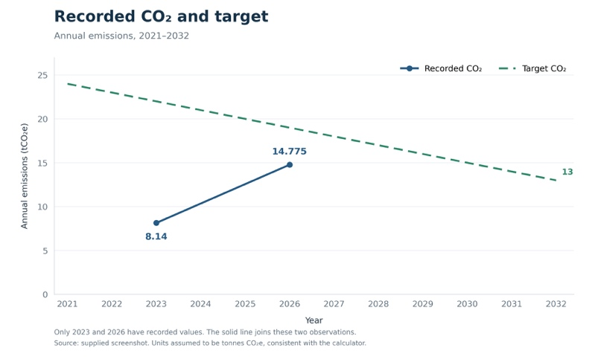
Note:2026 figures reflect increased activity and travel across all clients; CO2 production is impacted by volume of activity and modes of transport used.

Carbon Reduction Projects

Completed Carbon Reduction Initiatives
Although there has been an increase in recorded emissions, this is a direct consequence of the levels of travel for work which have been undertaken in 2025/6. Our focus remains on limiting the impact of travel by encouraging use of public transport and economy air travel, and to seek alternative to flying and car transport where possible. We also encourage the use of more carbon efficient vehicles where they have to be used, and encouraging changeover to green tariff electricity where possible.

In the future we hope to continue progress in these areas, as they are the major forms of emission we create.

Declaration and Sign Off
This Carbon Reduction Plan has been completed in accordance with PPN 06/21 and associated guidance and reporting standard for Carbon Reduction Plans.
Emissions have been reported and recorded in accordance with the published reporting standard for Carbon Reduction Plans and the GHG Reporting Protocol corporate standard and uses the appropriate Government emission conversion factors for greenhouse gas company reporting.
Scope 3 emissions have been reported in accordance with the published reporting standard for Carbon Reduction Plans and the Corporate Value Chain (Scope 3) Standard.
This Carbon Reduction Plan has been reviewed and signed off by the board of directors (or equivalent management body).

Signed on behalf of the Supplier:
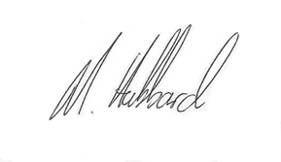
……………………………………………………………….
Date: …………12/10/2026…………….……….

Appendix A

Detailed Scope 3 Emissions

In addition to the required reporting, we have developed more detailed scope 1,2 and 3 emission records to help with our carbon reduction plan. These numbers are included in the scope 1,2 and 3 reporting in the main body of the plan.

Emission type | 2023 ( baseline year) (tCO₂e) | 2025/6 | 2025
Upstream waste and distribution | 0 | 0
Waste generated in operations | 0.1 | 0.1
Business travel | 8.04 | 14.6
Employee commuting | 0
Downstream transportation and distribution | 0

https://ghgprotocol.org/corporate-standard
https://www.gov.uk/government/collections/government-conversion-factors-for-company-reporting
https://ghgprotocol.org/standards/scope-3-standard

